# - Master Thesis -

Real-time Stereo Reconstruction for

View-corrected Augmented Reality on Mobile Devices

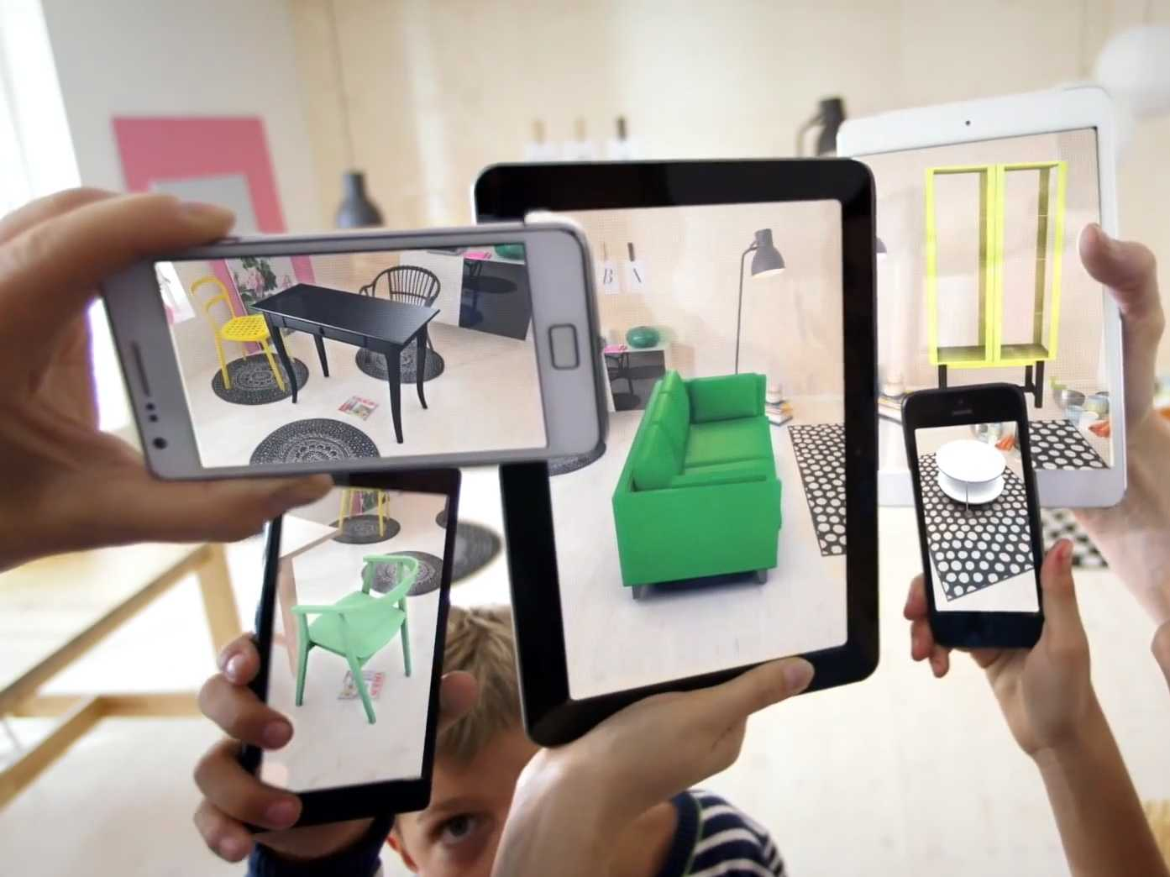 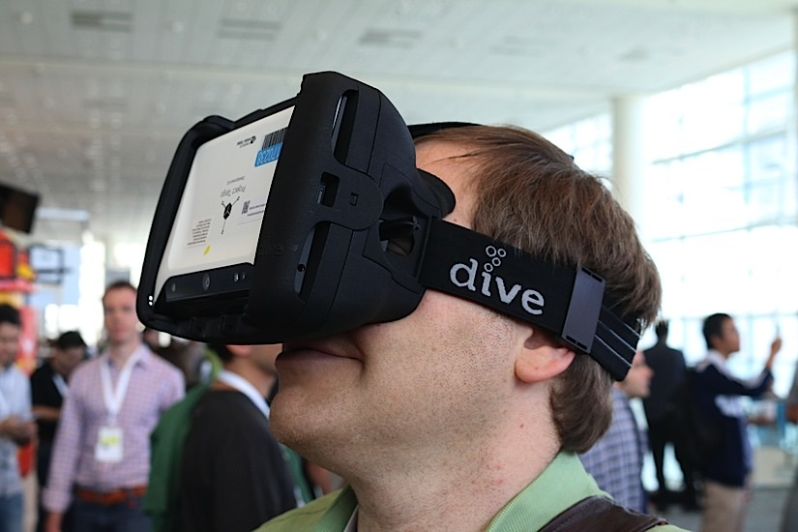 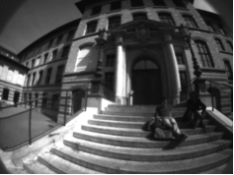 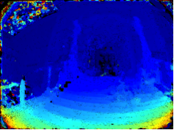

## Introduction

Mobile devices become increasingly popular for augmented reality applications. In current applications the augmented objects are directly overlayed on top of the original camera images. Depending on the camera’s field of view and position, the users view onto the scene through the device can be much different from the original view of the user onto the scene. This effect especially becomes stronger with a larger field of view of the camera, e.g. fisheye cameras. An example of this effect is shown in the first image[1].

The goal of this work is to compensate this effect by creating a real-time capable framework for undistorted vision of the real world with arbitrarily aligned camera sensors on a mobile device. To this end, a real-time stereo reconstruction method that models the geometric alignment between real and virtual camera views and which works for different combinations of camera sensors needs to be developed. The viewing experience can optionally be improved by dynamically computing the virtual camera view via head tracking. Another possible application uses two virtual camera views to enable undistorted stereo-vision on head-mounted devices (see second image). A simple augmentation of the camera view with a 3D object shall serve as a proof of concept.

## Goals

* Development of a real-time stereo reconstruction method using different camera sensors (pinhole, fisheye).
* Modeling the dependency between the device cameras and virtual camera views with associated calibration.
* Realistic real-time rendering of the real world in a virtual camera view on a mobile device.
* A simple augmented reality application for a proof of concept demonstration.

## References

[1] C. Häne, L. Heng, G. H. Lee, A. Sizov, M. Pollefeys, *Real-Time Direct Dense Matching on Fisheye Images Using Plane-Sweeping Stereo*, Proc. Int. Conf. on 3D Vison (3DV) 2014

[2] S. Abraham, W. Förstner, *Fish-eye-stereo calibration and epipolar rectification, ISPRS Journal of Photogrammetry and Remote Sensing*, Vol. 59, Issue 5, p. 278-288, 2005.

[3] Z. Zhu, *Omnidirectional stereo vision*, Proc. of the Workshop on Omnidirectinal Vision (OMNIVIS), 2001

[4] D.Gallup, J.-M.Frahm, P.Mordohai, Q.Yang, M.Pollefeys. *Real-time plane-sweeping stereo with multiple sweeping directions*. In Proc. of the Conference on Computer Vision and Pattern Recognition (CVPR), 2007

[5] S. Seitz, C Dyer, *View Morphing*, ACM SIGGRAPH, 1996

[6] R.I. Hartley, A. Zisserman, *Multiple view geometry in computer vision*, Cambridge University Press, 2004

## Thesis Grading

The thesis will be graded according to the following percentages:

40% **General:** commitment, methodology, autonomy, creativity, originality, personal ideas, theory,

general understanding of the topic, literature review

20% **Implementation:** appropriatness of the technique/methodology used,

documentation and reusability of hard- and software system

20% **Thesis:** structure, presentation, accuracy, clarity, clompleteness

20% **Presentation** (Mid-term and final presentation): Problem formulation, motivation, presentation of

the essential, quality of the means of presentation (slides, videos, demos), oral presentation, clarity

## Project information

Student: Shuoran Yang

Supervisor: Prof. Marc Pollefeys, [marc.pollefeys@inf.ethz.ch](mailto:marc.pollefeys@inf.ethz.ch)

Advisors: Martin Oswald, [martin.oswald@inf.ethz.ch](mailto:martin.oswald@inf.ethz.ch)

Torsten Sattler, [torsten.sattler@inf.ethz.ch](mailto:torsten.sattler@inf.ethz.ch)

Start date: September 1, 2015

End date: February 28, 2015

___________________ ___________________ ___________________

Shuoran Yang Prof. Marc Pollefeys Martin Oswald

Thesis Supervisor Thesis Advisor

1. Images from left to right by Ikea, [www.engadget.com](http://www.engadget.com) and [1].